**JAT TASK – 5**

**PALINDROME :**

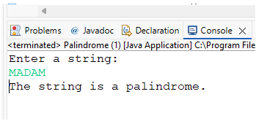

**REVERSE THE STRING :**

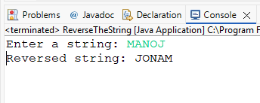

**NUMBER TRIANGLE :**

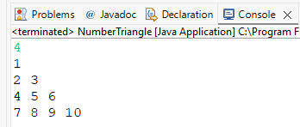

**STAR PATTERN :**

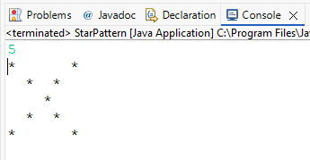

**GRADING SYSTEM :**

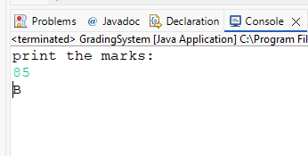

**HOTEL TARIFF :**

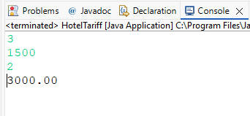

**LARGEST NUMBER :**

